Supplementary Material
In vitro and In vivo recombination of heterologous modules for improving biosynthesis of astaxanthin in yeast

Dan-Dan Qi^{1, 2}, Jin Jin^{1, 2}, Duo Liu^{1, 2}, Bin Jia ^{1, 2*} and Ying-Jin Yuan ^{1, 2}
¹Frontier Science Center for Synthetic Biology and Key Laboratory of Systems Bioengineering (Ministry of Education), Tianjin University, Tianjin 300072, China
²Collaborative Innovation Center of Chemical Science and Engineering (Tianjin), School of Chemical Engineering and Technology, Tianjin University, Tianjin 300072, China
* To whom all correspondence should be addressed:
Dr. Bin Jia
Email: bin.jia@tju.edu.cn
Email addresses for all authors: 2017207246@tju.edu.cn;2015207264@tju.edu.cn; liuduo19870401@126.com；bin.jia@tju.edu.cn; yjyuan@tju.edu.cn.
Figures

Fig. S1 HPLC analysis of the carotenoid producing strain. a Beta-carotene producing strain yQDD000 showed a onefold β-carotene peak at 20.2 min. b strain yQDD001 showed astaxanthin peak at 6.4 min along with other peaks for the identified intermediates, such as zeaxanthin (IV) at 7.5 min, canthaxanthin (III) at 10.5 min and lycopene (II) at 18.3 min.
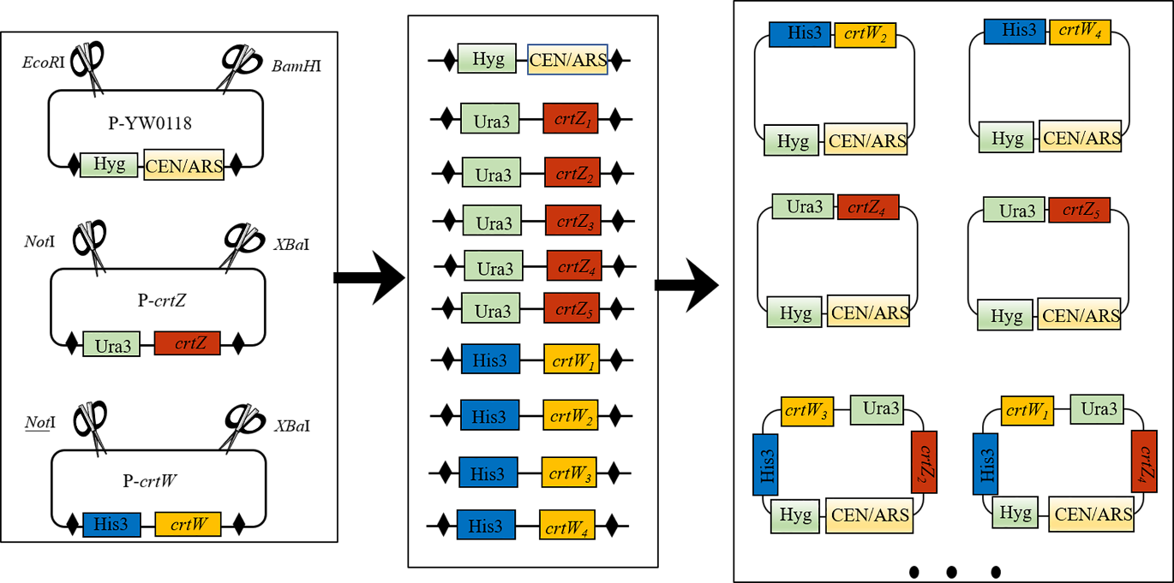 Fig. S2 Principle of the in vitro recombination. Marker of Hygromycin, Ura3 and His3 were used to screen the acceptor vector, crtZ and crtW donor vector respectively. Then acceptor fragments and donor fragments with loxpsym sites were exposed by restriction enzyme digestion, producing the in vitro recombination reaction pool. Next the pool of diverse plasmids was produced by the action of Cre recombinase. Reaction pool was transformed to target yeast and screening from the yeast library of different astaxanthin yield. The darker red colonies were selected for genotype and phenotype assay.

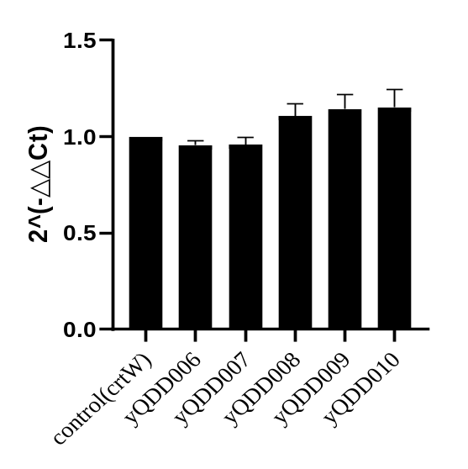
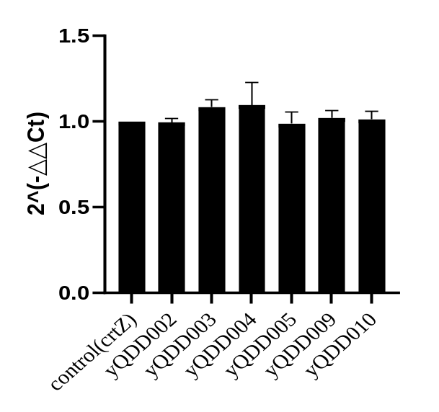
Fig. S3 Copy number analysis of crtZ and crtW in strains selected from in vitro recombination. a The copy number analysis of crtZ in yQDD002, yQDD003, yQDD004, yQDD005, yQDD009, yQDD010. b The copy number analysis of crtW in yQDD006, yQDD007, yQDD008, yQDD009, yQDD010.The results indicated that there have only one copy number of crtZ or crtW in the yQDD002-yQDD010.
Fig. S4 Homologous arm design of in vivo recombination. Ty1 retrotransposition site is consisted of TyA and TyB. And there are two δ sites on the each side of Ty1 site. Two homologous arms of Ty-1 and Ty-2 from TyA are used to flank the crtZ/crtW fragment for the in vivo recombination
Fig. S5 Principle of the in vivo recombination. The DNA fragments of in vivo recombination were linearized by the digestion of NotI. Then the pool of all the DNA fragments was transformed into yQDD001, generating the yeast library with different color. The darker red colonies were selected for genotype and phenotype assay.
Fig. S6 Copy number analysis of crtZ and crtW in strains selected from in vivo recombination. a The copy number analysis of crtZ in yQDD011, yQDD012, yQDD013, yQDD017, yQDD018, yQDD019, yQDD020, yQDD021 and yQDD022. b The copy number analysis of crtW in yQDD014, yQDD015, yQDD016, yQDD017, yQDD018, yQDD019, yQDD020, yQDD021, yQDD022.
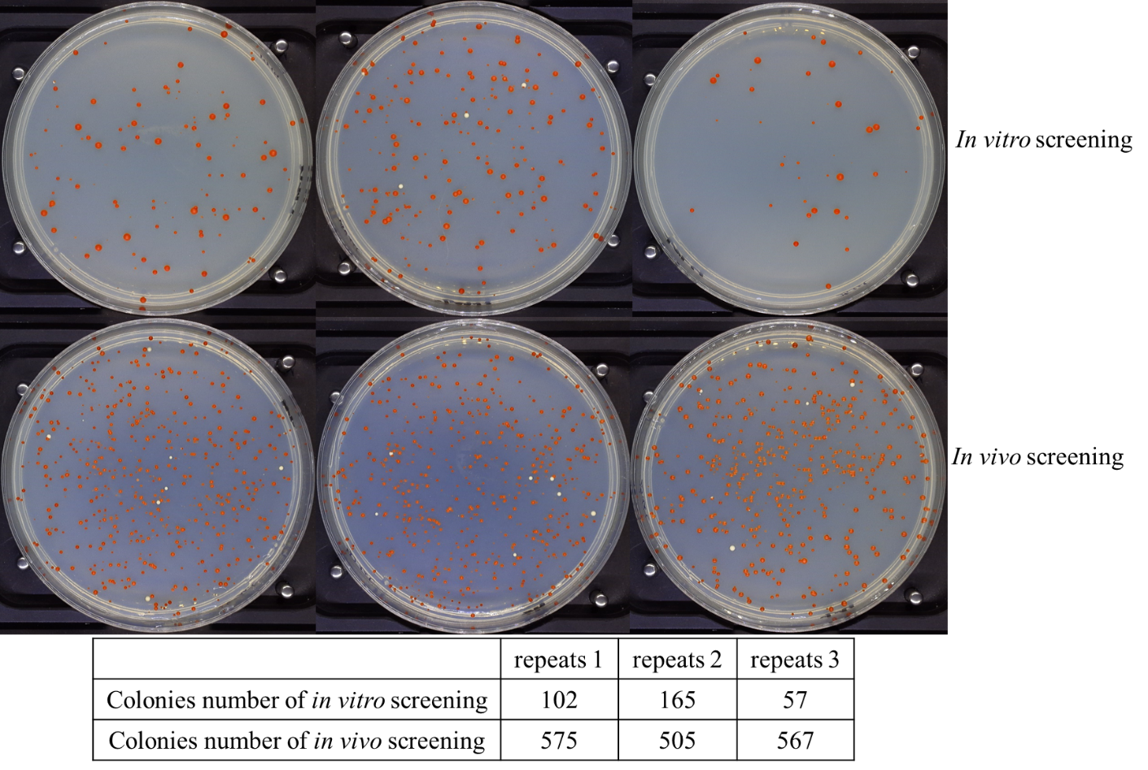
Fig. S7 Transformation efficiency comparison between in vitro and in vivo recombination. The colony's number after yeast transformation with three biological repeats was used to assess the efficiency of in vitro and in vivo recombination. All the experimental conditions remained consistent, including the concentration of DNA fragment of crtZ and crtW, The biomass of host strain yQDD001 and other operating environments. Photograph of in vitro and in vivo screening was attached. The colony's number was listed in Fig. S6. Compared with in vitro recombination, the many more colonies of in vivo screening indicating the high transformation efficiency of the in vivo recombination.

Fig. S8 Color stability assay of yQDD008 and yQDD022. The yQDD008 and yQDD022 were serially subcultured in YPD for 6 days and screened on SD agar each day.

Fig. S9 Profile of glucose titer during fermentation in 250-mL flask with strain yQDD008 and yQDD022.

Table
Table S1 PCRTag used in this study
Name | Sequences
tag1 | ACAAGGATTTTTGACGGTGC
tag2 | AAAGCATCGTAGCACTGCTC
tag3 | GAGCCTTTGATCGCAATCTT
tag4 | CGAGCGACAGACTGGTATTC
tag5 | GTCGTTGAGTACCGGCATCA
tag6 | GGCTGAGATCAAAGGCGGTT
tag7 | CGGCAAAGCTGGTTTGAATT
tag8 | GATATCGTTGAGCAGCTTGG
tag9 | CATTTGGTACTGGCCAGACC

Table S2 Primers used in this study
Name | Sequences | Description
Z₁+1pcrtag-R | CGCTCTTATTGACCACACCTCGCACCGTCAAAAATCCTTGT | Amplification of crtZ₁ with 1PCRTag
Z₁+1pcrtag-F | GCACCGTCAAAAATCCTTGTTACCGGCATGTCAATTCATCAT | Amplification of crtZ₁ with 1PCRTag
Z₂+2pcrtag-R | CGCTCTTATTGACCACACCTCGAGCAGTGCTACGATGCTTT | Amplification of crtZ₂ with 2PCRTag
Z₂+2pcrtag-F | GAGCAGTGCTACGATGCTTTTACCGGCATGTCAATTCATCAT | Amplification of crtZ₂ with 2PCRTag
Z₃+3pcrtag-R | CGCTCTTATTGACCACACCTCAAGATTGCGATCAAAGGCTC | Amplification of crtZ₃ with 3PCRTag
Z₃+3pcrtag-F | AAGATTGCGATCAAAGGCTCTACCGGCATGTCAATTCATCAT | Amplification of crtZ₃ with 3PCRTag
Z₄+4pcrtag-R | CGCTCTTATTGACCACACCTCGAATACCAGTCTGTCGCTCG | Amplification of crtZ₄ with 4PCRTag
Z₄+4pcrtag-F | GAATACCAGTCTGTCGCTCGTACCGGCATGTCAATTCATCAT | Amplification of crtZ₄ with 4PCRTag
Z₅ +5pcrtag-R | CGCTCTTATTGACCACACCTCTGATGCCGGTACTCAACGAC | Amplification of crtZ₅ with 5PCRTag
Z₅ +5pcrtag-F | TGATGCCGGTACTCAACGACTACCGGCATGTCAATTCATCAT | Amplification of crtZ₅ with 5PCRTag
W₁+6pcrtag-R | CACACTAATTGGCTTTTCGCAACCGCCTTTGATCTCAGCC | Amplification of crtW₁ with 6PCRTag
W₁+6pcrtag-F | AACCGCCTTTGATCTCAGCCATTGGTGAGCGCTAGGAG | Amplification of crtW₁ with 6PCRTag
W₂ +7pcrtag-R | CACACTAATTGGCTTTTCGCAATTCAAACCAGCTTTGCCG | Amplification of crtW₂ with 7PCRTag
W₂ +7pcrtag-F | AATTCAAACCAGCTTTGCCGATTGGTGAGCGCTAGGAG | Amplification of crtW₂ with 7PCRTag
W₃+8pcrtag-R | CACACTAATTGGCTTTTCGCCCAAGCTGCTCAACGATATC | Amplification of crtW₃ with 8PCRTag
W₃+8pcrtag-F | CCAAGCTGCTCAACGATATCATTGGTGAGCGCTAGGAG | Amplification of crtW₃ with 8PCRTag
W₄+9pcrtag-R | CACACTAATTGGCTTTTCGCGGTCTGGCCAGTACCAAATG | Amplification of crtW₄ with 9PCRTag
W₄+9pcrtag-F | GGTCTGGCCAGTACCAAATGATTGGTGAGCGCTAGGAG | Amplification of crtW₄ with 9PCRTag
Z-F | TGGTAGATACGTTGTTGACACTTC | PCRTag analysis of crtZ
w-F | ACCTGAAGCATAACTGACACTAC | PCRTag analysis of crtW
tag1-R | ACAAGGATTTTTGACGGTGC | PCRTag analysis
tag2-R | AAAGCATCGTAGCACTGCTC | PCRTag analysis
tag3-R | GAGCCTTTGATCGCAATCTT | PCRTag analysis
tag4-R | CGAGCGACAGACTGGTATTC | PCRTag analysis
tag5-R | GTCGTTGAGTACCGGCATCA | PCRTag analysis
tag6-R | GGCTGAGATCAAAGGCGGTT | PCRTag analysis
tag7-R | CGGCAAAGCTGGTTTGAATT | PCRTag analysis
tag8-R | GATATCGTTGAGCAGCTTGG | PCRTag analysis
tag9-R | CATTTGGTACTGGCCAGACC | PCRTag analysis
Hph-F | CGAAGTTATCCCAGGTCGCTCGTCCCAAAACCTTCTCAAGC | Amplification of Hyg
Hph-R | CCACCGCGGTGGCGGCCGCTGCATCAGAGCAGATTGTACTGAGAG | Amplification of Hyg
Hph-test-1-F | ACTCTTTGATAACGTCTTCGGAGG | Verification for Hyg
Hph-test-1-R | TGTAGAAGTACTCGCCGATAGTGG | Verification for Hyg
Hph-test-2-F | TGTTCGGATGTGATGTGAGAACTG | Verification for Hyg
Hph-test-2-R | CGAACTGAGATACCTACAGCGT | Verification for Hyg
crtW-F | TGTGACCGTAAAACGACGGCCAGTCAGTTCGAGTTTATCATTATCAATAC | Amplification of crtW
crtW-R | AATGCATCAGGAAACAGCTATGACCTACATAAGAACACCTTTGGTGGAGG | Amplification of crtW
crtZ-F | TTGTGACCGTAAAACGACGGCCAGTTCCAACTGGCACCGCTGGCTTGAAC | Amplification of crtZ
crtZ-R | AAATGCATCAGGAAACAGCTATGACTTAGTTTTGCTGGCCGCATCTTCT | Amplification of crtZ
Ty-F | GTCATAGCTGTTTCCTGATGCATTTGAAACAAAAGTCACAAAC | Amplification of Ty homologous arm
Ty-R | ACTGGCCGTCGTTTTACGGTCACAATGTCGTTTGCCTCT | Amplification of Ty homologous arm

